Terence Monama

ST10405691

WEDE5020

PoE Part 2

Changes made

1st changes made are on navigation. The format of navigation makes the nav bar not fit on smaller devices. So I thought I should change to something that will fit on mobile devices since we are making websites for everyone not desktop and tablet user only. These changes are below the header on each page.

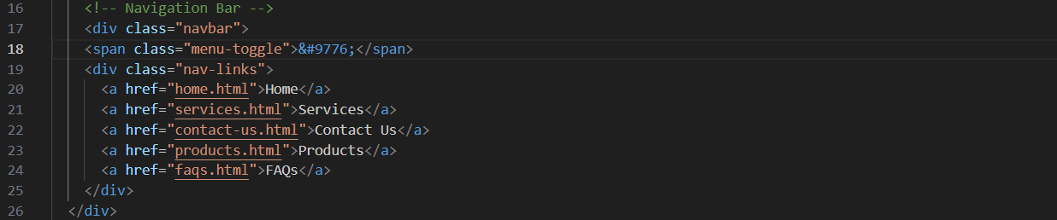

2nd changes were on FAQs file where I removed code for displaying a gloria chair on the back round on that FAQs box. The reason was because of the colors. I’m aware that some colors might be placed where there is the same color on that furniture which will make some letters invisible.

3rd changes are in the header on the FAQs file. Why changed? I realized that I set wrong size on the company logo. It was changed so it could align with other logo.

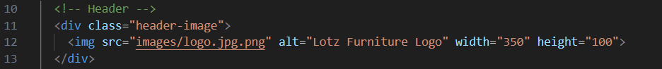

Screenshots of different sizes

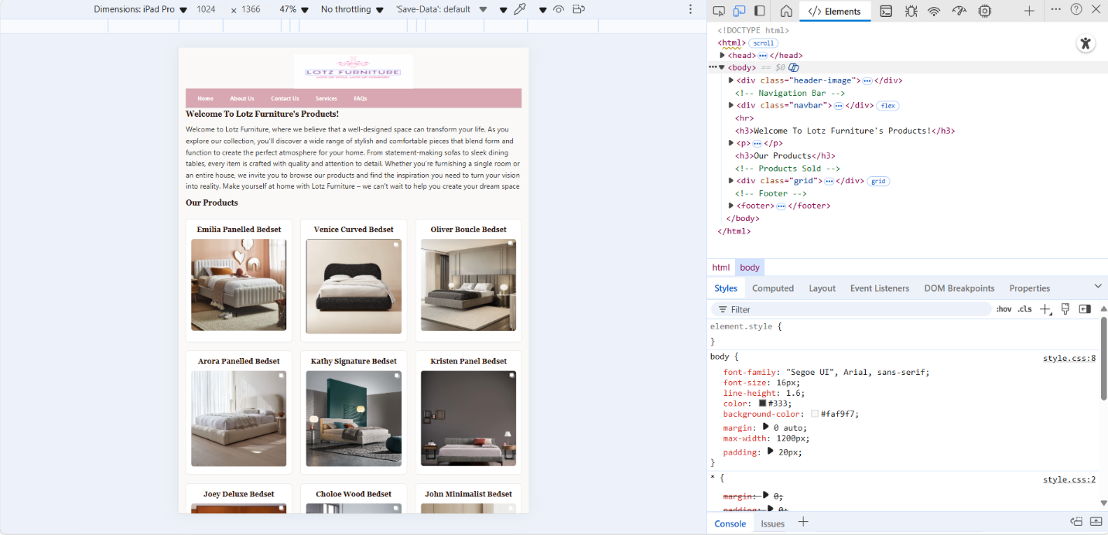

Reference list

* W3schools. Research for CSS tutorials. Available online [CSS Tutorial](https://www.w3schools.com/css/default.asp).